All own attendance statistics report – groups of students attendance by name and a summary at the bottom

Complete as below and report will generate as on next page

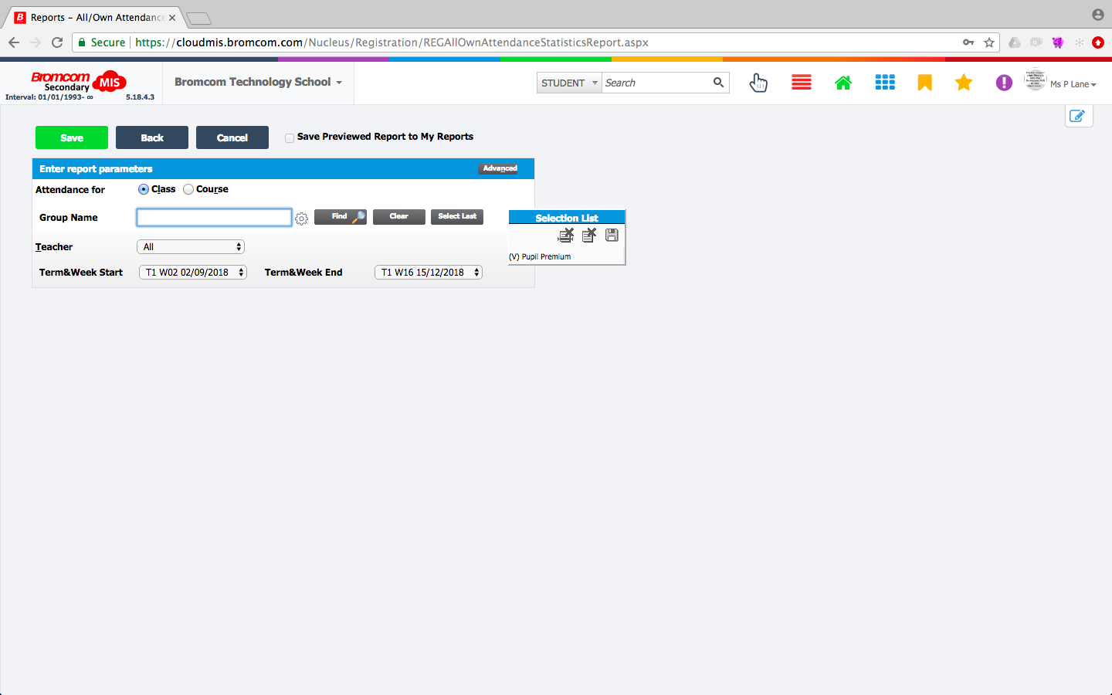

This report can display lists of children by
- Groups (Dis,EAL etc)
- Tutor groups
- Year Groups
- Houses
- Classes
- Report Groups

All of these can also be filtered by year group, house, department, faculty
