Register Audit Report
This Report allows you to identify which User/Staff Member has made changes to a Student or a Classes Attendance.
A great Report for identifying changes made to Attendance, whether they were accidental or intended.
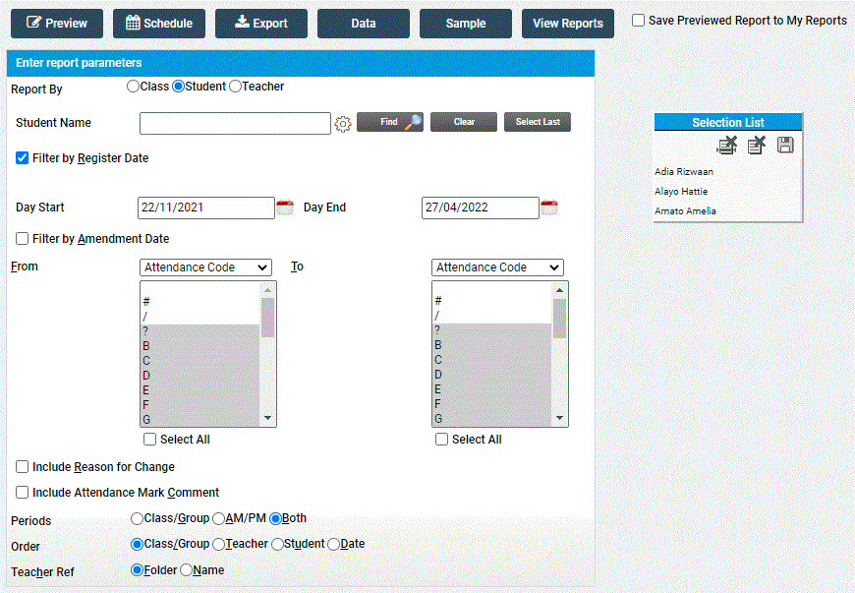

This Report can be run by Student, Teacher or Group and allows you to identify changes to particular periods and look for specific Attendance Codes across a chosen date range.

