Commented Attendance –All students with attendance comments in the set date range.

Complete as below and report will generate as on next page

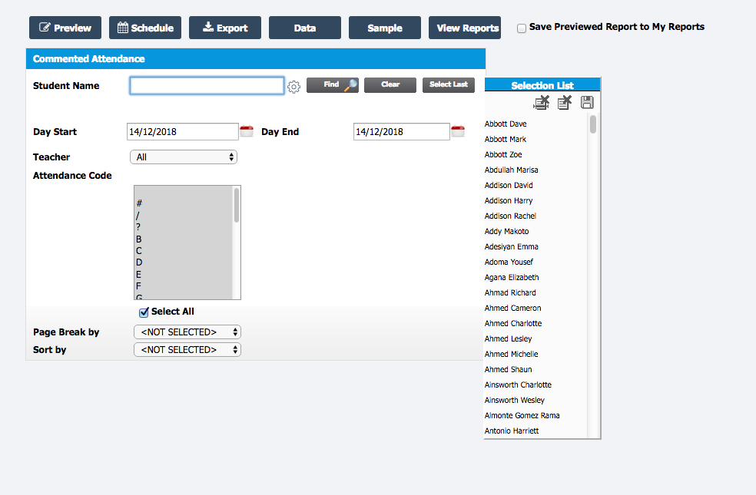

This report can display individual students and comments by
- Whole school
- Groups (Dis,EAL etc)
- Tutor groups
- Year Groups
- Houses
- Classes
- Report Groups

