Attendance History – lists of students and their attendance – good for persistant absence and 100% attendance reports

Complete as below and report will generate as on next page – note the % attendance threshold, this can be altered to show persistent absence/100% etc

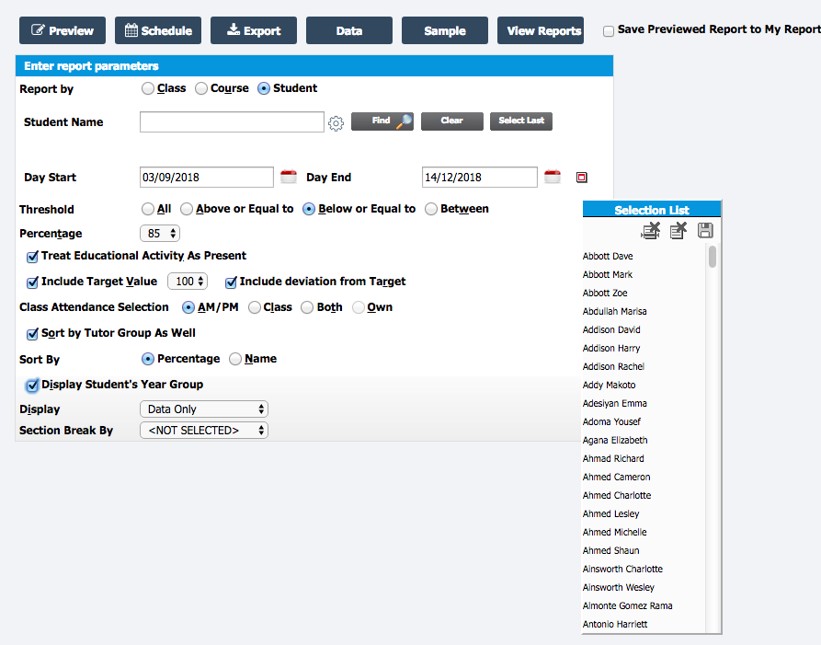

This report can display lists of children by
- Whole school
- Groups (Dis,EAL etc)
- Tutor groups
- Year Groups
- Houses
- Classes
- Report Groups

All of these can also be filtered by year group, house, department, faculty

The report below shows students below 85% attendance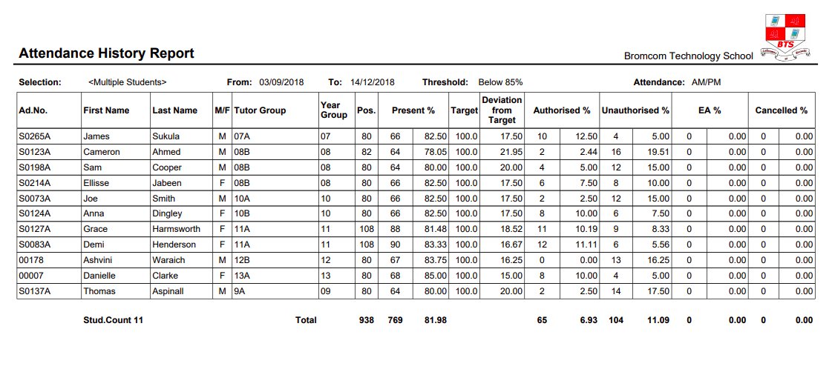
This report shows students with 100% attendance

